Report – Advanced Web Technologies CW2

**Introduction**

**I have created a web app which stores details of films and actors in a database. It is possible to add films to the database through a form, and you can then view the submitted additions on the films page. You can view all the films and actors on the appropriate pages through navigation bar. There is a search function in which you can search through the film entries, this uses a wildcard so it will display all entries containing the search terms. The search is displayed on every page except the Welcome and Add page.**

**Design**

**The web app is designed to be easy to navigate, it includes a simple navigation bar and search box at the top of the page.**

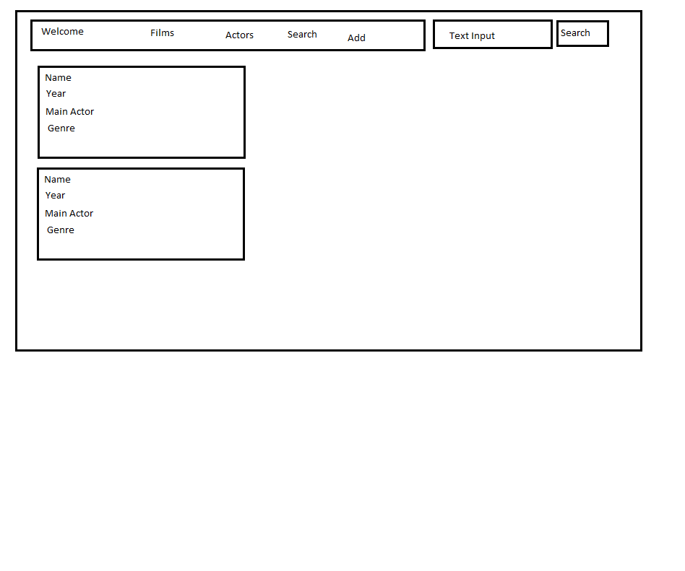

**On the films and actors pages it displays the information stored in the database in an easy to read manner. Due to the fact that I designed the website to be basic, it is a simple interface of navigation bar and search.**

**When on the Add page, the form to add to database is simple to use.**

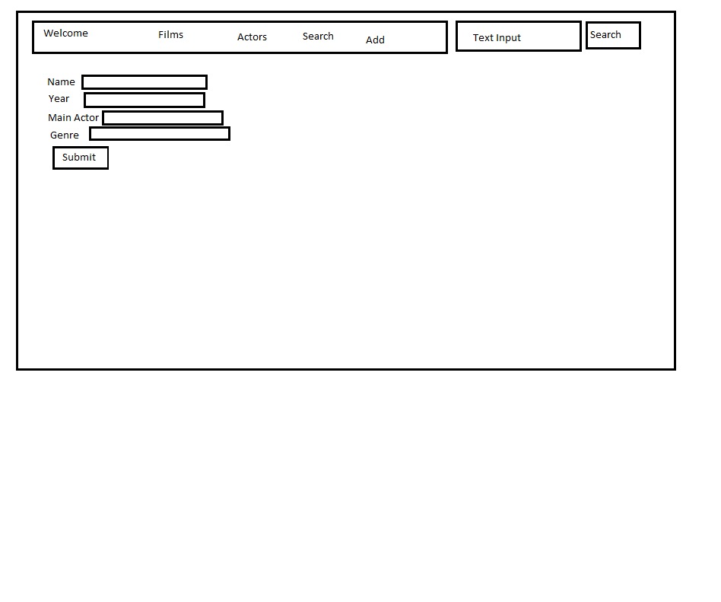

**The app also uses a templates and static folder, one for HTML Templates, the other for the CSS Stylesheet. This reduces the CSS being copied in every HTML file.**

**Enhancements**

**It is a fairly basic web app at the minute, however the addition of being able to add to the database is something I am happy with. Searching through the actors as well as films would be an improvement to the search function. Also being able to add to the actor database table would be another improvement. This would most likely be achieved through radio buttons to select which table to input into. I would have liked to use Bootstrap and other external libraries to improve the website however every attempt at using these resulted in failure. I would also have liked to implement a login system for users, using cookies.**

**Critical Evaluation**

**It is a basic web app, however it functions in everything it attempts to do. It will display the database data on the appropriate pages and you are able to add to the database very easily. It would be better if the data from the database was able to be ordered by year, or another category. It is currently just alphabetical. All navigation bar functions work, and adding the database is simple. The search box works as intended, however being able to search actors as well as films would be good. It isn’t possible to see all the films the actors are in, this would be a good addition to the app.**

**Personal Evaluation**

**The web app is basic, however I am happy with being able to add to the database. My intention was to create a blogging app which would use external libraries and logins. I found however that whenever I used external libraries I encountered errors and failed to fix them. Through failing to do that however, my knowledge of using libraries has definitely been expanded and useful to try and successfully use them in the future. I was also intending to use bootstrap to give the page visual enhancements but I again had issues using the external library. Having these issues however definitely gave me greater understanding of Flask and Levinux when trying to troubleshoot problems. I’m comfortable with SQLite3 and working out how to add to the database from user added to that knowledge. I’d have liked to put more features into the site, especially a login, however the issues I am across stopped me from doing so.**

**Summary of Resources**

<http://www.w3schools.com/> - Getting back to grips with HTML and CSS

<http://flask.pocoo.org/> - Useful for trying to use external libraries

<http://opentechschool.github.io/python-flask/extras/databases.html> - Used when trying to use user input to add to database